Name: Martin Bath
Group: 29

Personal Reflection Statement
The Group was put together during class where members had no previous interactions with each other, so I took the initiative and had everyone state their background, interests and whether the client or entrepreneur route was preferred. As all members expressed a preference for the entrepreneur route, we needed a project. I booked a meeting room for a short time later and suggested we all bring three suggestions. In the meantime, I created the Group Github repository and Trello boards and added all members to them.
At the first meeting, all members arrived but only I had brought ideas with me. First lesson learned, not everyone attaches the same value to suggestions and events as you do so have a contingency and be prepared to be adaptable.
Group seemed open to my suggestions and we voted on preferred project. I drew up diagrams to explain all three and filled out the project form with them.

As we had chosen a game creation project (CardRule), two group members had previous experience with Unity game engine, so this was chosen as the preferred development tool. Myself and one other member had no prior experience with Unity but were prepared to learn this as soon as possible.
My initial intention was to create the AI portion of the project to operate as the opponent in the card game in a pseudo AI method, where it went through available options and scored them. In the meeting with the tutor was suggested that this may be too ambitious given the time constraints and suggested using a AI tool and/or AI Agent to perform the work.
In the tutor meeting, the balance of roles was adjusted and I passed the management / documentation portion over to another member, so they could develop themselves and contribute to the project, whilst I concentrated on the AI side.
I investigated various AI software including ChatGPT, Google Gemini, Claude, Perplexity, Meta AI. XGrok, and Copilot for cost, functionality, documentation (Wotnot.io 2025) . In reading around the topic, it became clear that the AI software landscape is fast moving and volatile. Software chosen now, may not be available come May / June 2026. Chang (2025) notes that AI companies often plan only a few months ahead because the technology is evolving so fast.
This volatility made the overhead of creating AI agents in any one piece of software particularly unattractive, if it risked the requirement of rewriting it in a few months, adjacent to the project deadline. The choice came down to software from a major player, likely to be around for the next 12 months, at least, together with documentation, support from the development community and a free model to work with on a conversational level. Google Gemini appeared to be the front runner for this and there was a demo in Unity for call to Gemini. This sealed the choice so the next step was to load Unity, load the demo and get it working. The size of Unity proved a headache to save the code with Github but eventually, this was solved using tips from the internet regarding which libraries to ignore and which to include.

After gaining some knowledge in Unity, I managed to create a version of the demo to pass criteria to Gemini and receive the response. After several iterations of this, a working AI opponent was created.
This was then released to the team for integration with graphics and gameplay to produce a working prototype of a game where rules were sent to the Gemini.
Team adopted my suggestion of moving meetings to Zoom to aid attendance. This may need to revert to in-person meetings as integration proceeds.
The final version, in the second semester, will need to handle a list of possible solutions where AI does not know which rules are in play.
In working in the group, I have had to learn to be more patient and trust people more, supporting them to succeed.
As we enter the second phase of the project, this will become even more crucial and we will have to work more collaboratively as the portions of the project become more integrated.

Appendix – Evidence
Original project suggestions
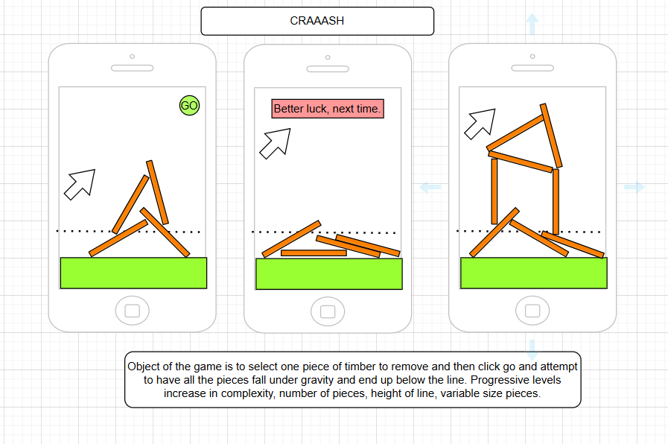
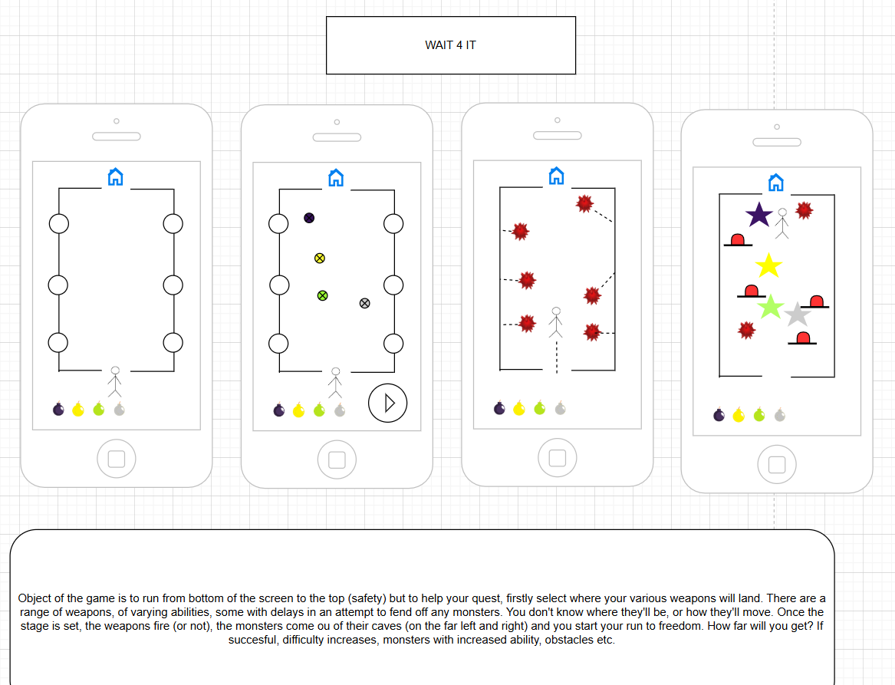
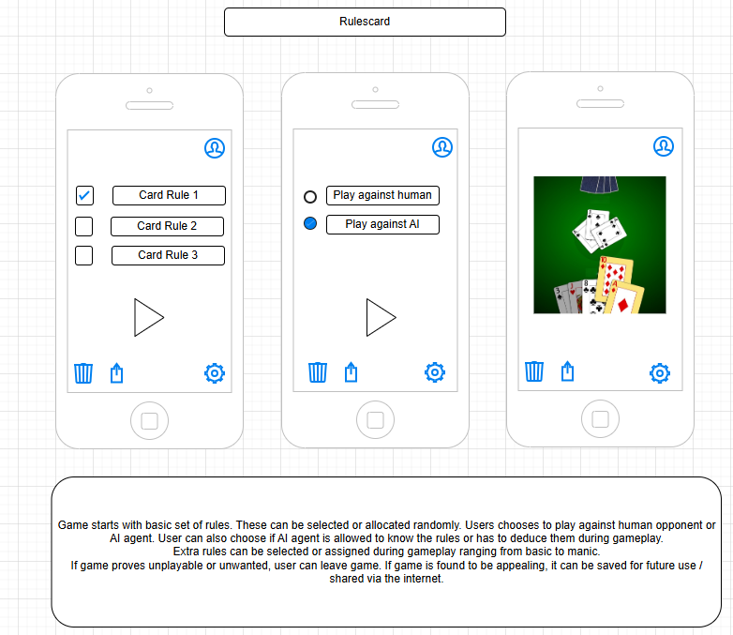

Github History
e01a1be | Tom Payne | 2025-12-12 | Add files via upload
95d8fda | Martin Bath | 2025-12-11 | Merge pull request #1 from Plymouth-University/Martin-2025-12-08
cb04b2f | Martin Bath | 2025-12-11 | Amended to return hand after the go
a764890 | Martin Bath | 2025-12-11 | Working test hand
6a87d4f | Martin Bath | 2025-12-10 | Added debug-http fails 403
98adaf8 | Martin Bath | 2025-12-09 | WIP loaded test call
7e9de66 | Martin Bath | 2025-12-08 | WIP for JSON integration
51d3ac8 | Martin Bath | 2025-12-05 | Stop tracking ignored files
4eb5f63 | Martin Bath | 2025-12-05 | adding extra gitignores
aedd3fb | Evan | 2025-12-04 | Add files via upload
077d3eb | Tom Payne | 2025-12-01 | Add files via upload
2c5895f | Tom Payne | 2025-12-01 | Add files via upload
dceaf31 | Tom Payne | 2025-12-01 | Add files via upload
ba3a274 | Martin Bath | 2025-11-30 | Copy base project
459bc22 | Martin Bath | 2025-11-30 | cleared cache
1f988e5 | Martin Bath | 2025-11-30 | Fix: apply .gitignore
ac425f4 | Martin Bath | 2025-11-29 | remove
edb1152 | Martin Bath | 2025-11-29 | unity upload1387
03b6c71 | Martin Bath | 2025-11-29 | create gitattributes
f4c08e0 | Martin Bath | 2025-11-29 | Create .gitignore
e1638d2 | Martin Bath | 2025-11-29 | removed old
ea7c7aa | Martin Bath | 2025-11-29 | amended git ignore and added gitattributes
fe7dcf1 | Martin Bath | 2025-11-28 | removed
1ff97b4 | Martin Bath | 2025-11-28 | 56
f96d66c | Martin Bath | 2025-11-28 | 9876
951a045 | Martin Bath | 2025-11-28 | 12
dfdbe1a | Martin Bath | 2025-11-28 | 123
fe1772a | Martin Bath | 2025-11-28 | c2
751f951 | Martin Bath | 2025-11-28 | q2

Trello Screenshot of completed boards
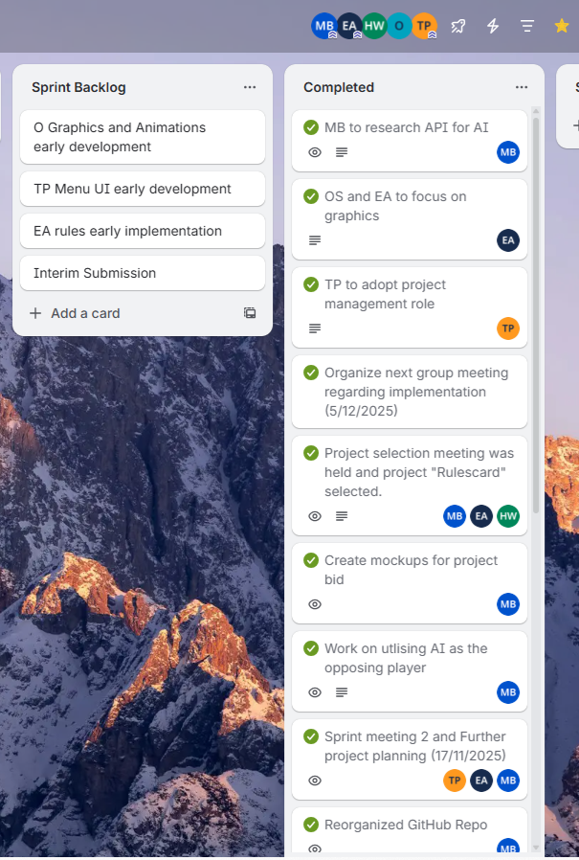
Piece of Code showing example call to AI
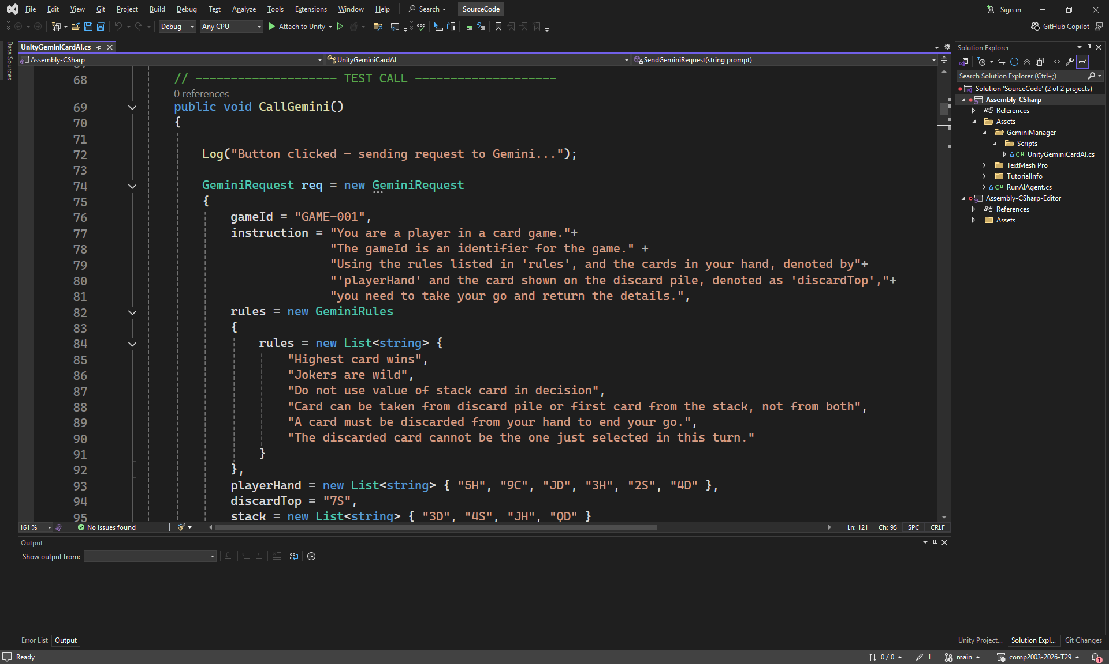
Definition of JSON to / from Gemini API’s
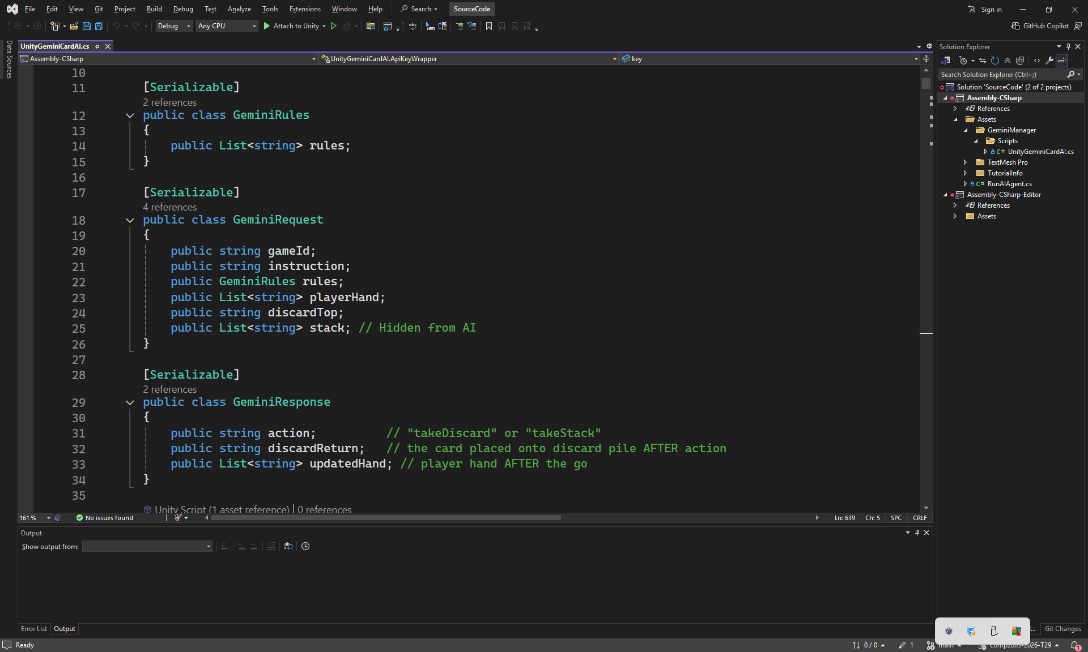

Google Gemini AI Plan page
- All plans
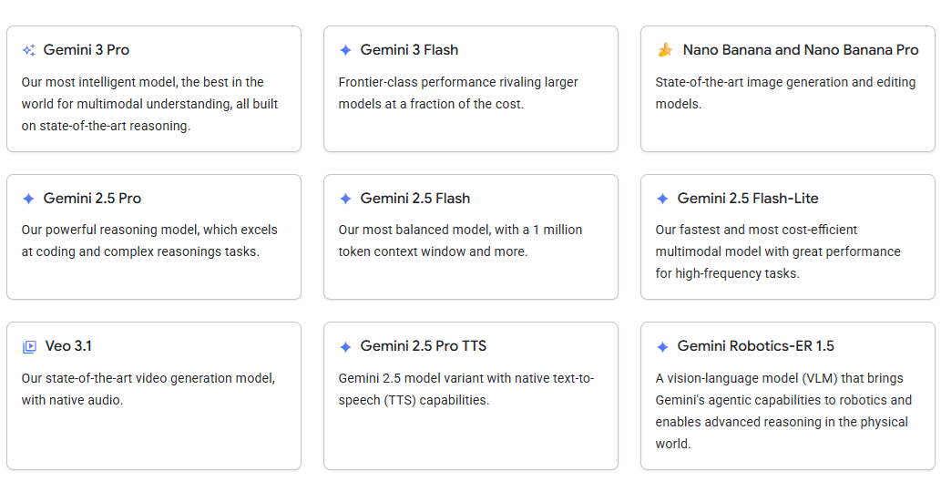
- Selected plan
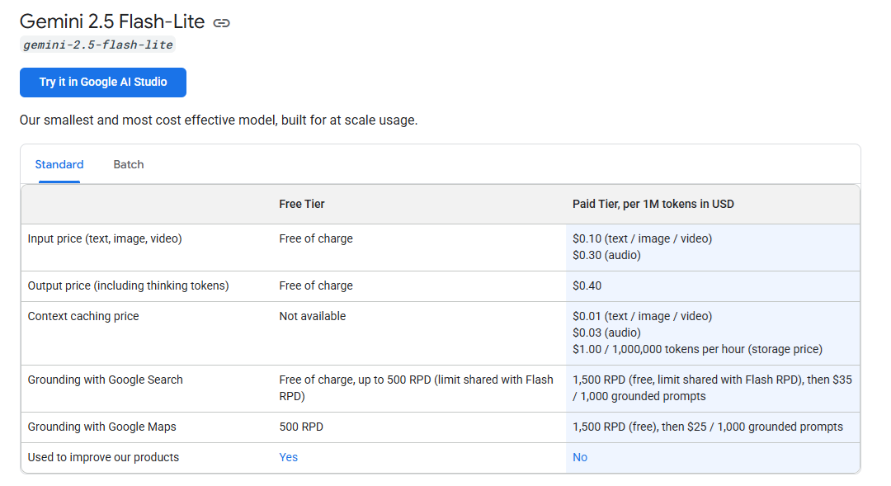

References
https://wotnot.io/blog/chatgpt-alternatives (Accessed 28 December 2025)
Chang, E. (2025) How fast are AI companies evolving? Check this out. Harvard Business School. Available at: https://www.hbs.edu/bigs/perplexity-aravind-srinivas (Accessed: 28 December 2025)

